**Protocolos de Ligação de dados:**

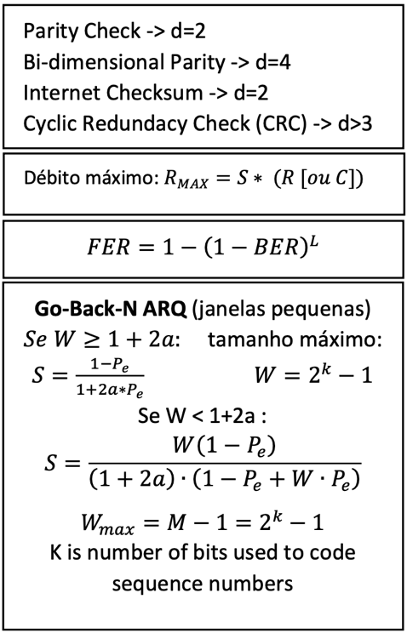**Intro:**

Physical Layer:**

**MAC:**

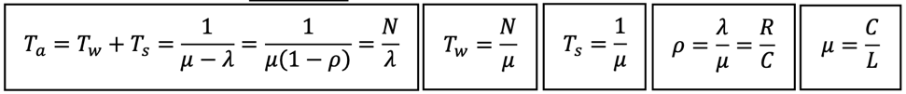**Filas de Espera 1:**

**Filas de Espera 2:**

Extra:**

**Transport:**